**Laboratory course - MATLAB Report (Group – 7)**

**Members:**

Prinson Joel Pereira: ej60osac

Gojo George: ny91woqo

Abdul Rameez b: oz98esiq

**What are the main components of an optimization problem?**

The main components of optimization problem are:

**Objective function**: Function that needs to be optimized

**Constraints**: condition to be satisfies- eg: maximum stress limits at truss

**Decision variables**: Their values need to be changed to optimize the solution eg: Cross sectional area

**Inputs**: Constants that define the problem eg: Modulus of elasticity

**Assign the following terms to the main components from question 1 according to their use in the experimental task.**

**Total axial stiffness/mass :** Constraints

**Cross-sectional area of the beam**: Decision Variable

**Displacement at the load application node:** Objective function

**Stress:** Constraints

**Plots from each subtask:**

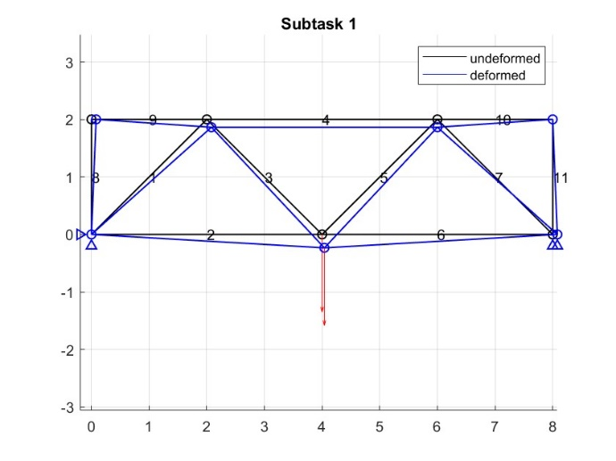 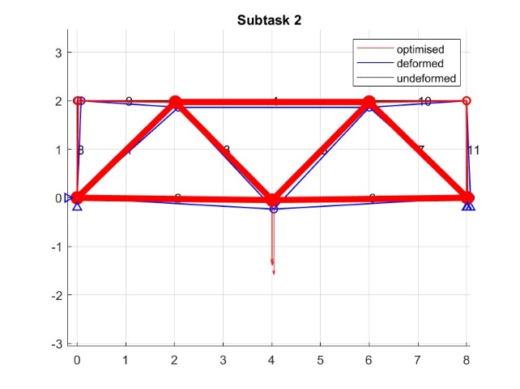

*Deformed and undeformed truss Optimised truss structure*

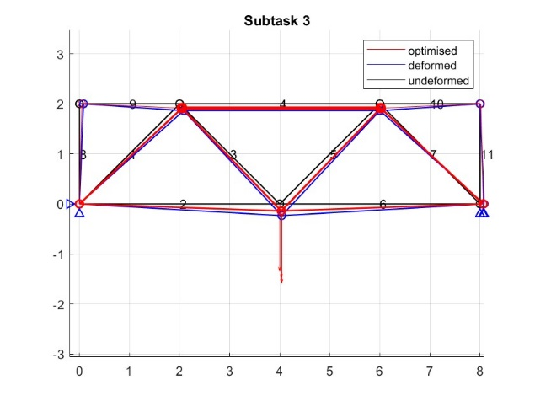 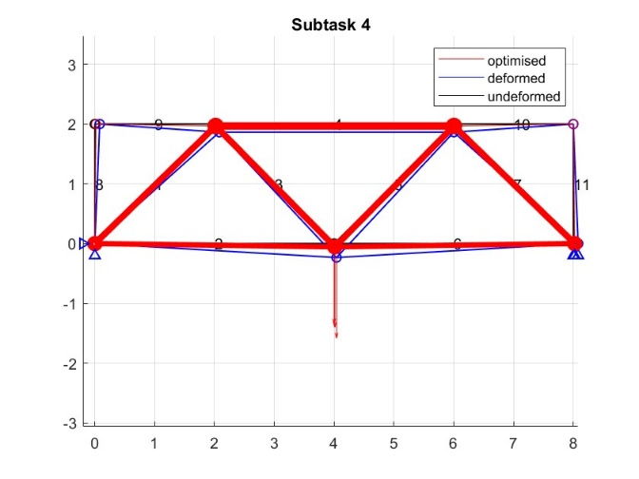

*Optimized truss with constraint (stiffness) Optimized truss with constraints (stiffness and stress)*

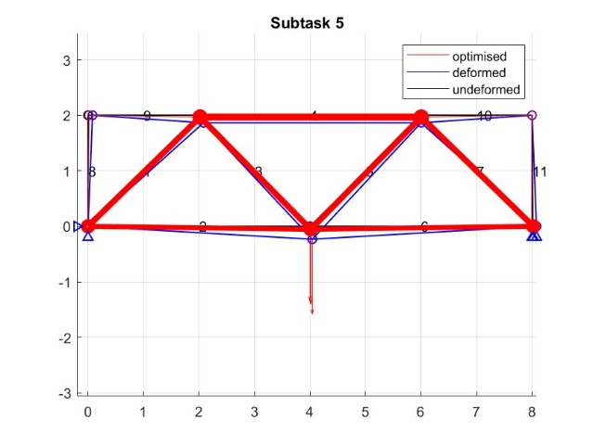 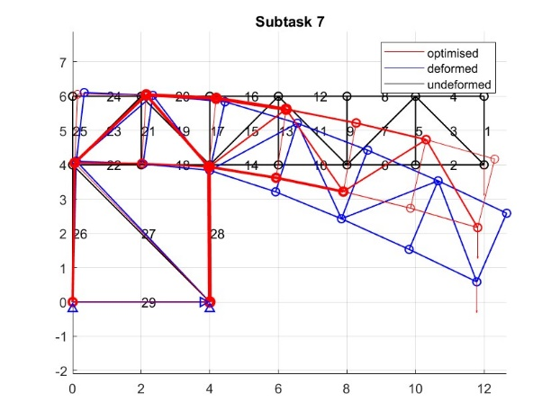

*Truss structure (efficiency of optimization) Optimised crane structure*

**Results:**  For optimized crane structure:

Optimised y displacement = -1.8299

|  |  |  |
| --- | --- | --- |
| **EA_scaled** | **x_opt** | **u** |
| 0.75 | 0.01 | -0.1885 |
| 48.6629 | 0.6488 | -1.8299 |
| 81.8417 | 1.0912 | 0.3087 |
| 0.75 | 0.01 | -1.8299 |
| 0.75 | 0.01 | -0.1474 |
| 48.6634 | 0.6488 | -1.2637 |
| 81.8418 | 1.0912 | 0.3087 |
| 97.3267 | 1.2977 | -1.2637 |
| 0.75 | 0.01 | -0.1063 |
| 145.9898 | 1.9465 | -0.7796 |
| 81.8415 | 1.0912 | 0.2676 |
| 97.3265 | 1.2977 | -0.7796 |
| 0.75 | 0.01 | -0.0652 |
| 145.9898 | 1.9465 | -0.3778 |
| 81.8413 | 1.0912 | 0.2265 |
| 194.6527 | 2.5954 | -0.3778 |
| 0.75 | 0.01 | -0.0241 |
| 97.3264 | 1.2977 | -0.0581 |
| 163.6827 | 2.1824 | 0.1854 |
| 194.6527 | 2.5954 | -0.0581 |
| 0.75 | 0.01 | 0.017 |
| 97.3264 | 1.2977 | 0.0411 |
| 163.6828 | 2.1824 | 0.1443 |
| 0.75 | 0.01 | 0.0411 |
| 0.75 | 0.01 | 0.0581 |
| 137.6405 | 1.8352 | 0.0581 |
| 0.75 | 0.01 | 0.1443 |
| 206.4604 | 2.7528 | 0.0581 |
| 0.75 | 0.01 | 0 |
|  |  | 0 |
|  |  | 0 |
|  |  | 0 |